Dublin Airport flies high with energy efficient lighting savings
It upgraded to LED lights at its car parks in Terminal One
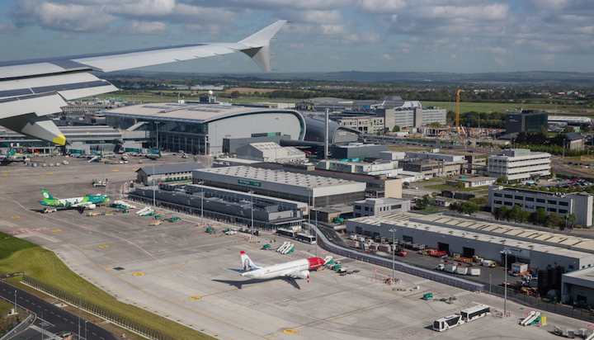
Image: Agatha Kadar/Shutterstock
Dublin Airport Authority (DAA) has achieved cost savings of around €80,000 (£71,785) following an energy efficiency upgrade.
It installed 304 LED lights in the multi-storey car parks and 386 in the surface car parks in Terminal One, which can be controlled individually and the level of lighting can be changed to suit the operational need and capacity at a given time.
The airport’s estimated electrical savings since November last year have totalled almost 964,500kWh to date – the equivalent of powering around 1,200 floodlights a year, according to the Sustainable Energy Authority of Ireland (SEAI).
The lighting at the car park accounts for 70% of the airport’s energy usage.
Martin McGonagle, Asset Care Head of Energy, Environment and Utilities at DAA said: “We have received really positive feedback from car park operations on the new system. The new lights give a lovely bright white glow and with the touch of a button, they can dim or enhance the lighting in an area.
“People are becoming more aware of the climate and the environment and it is important for companies to take action where they can to reduce the impact of their operations.”
The airport received funding through the SEAI’s Excellence in Energy Efficient Design (EXEED) certification programme, which encourages innovation in designing and managing projects.

