Urgent need to reduce reliance on fossil fuels

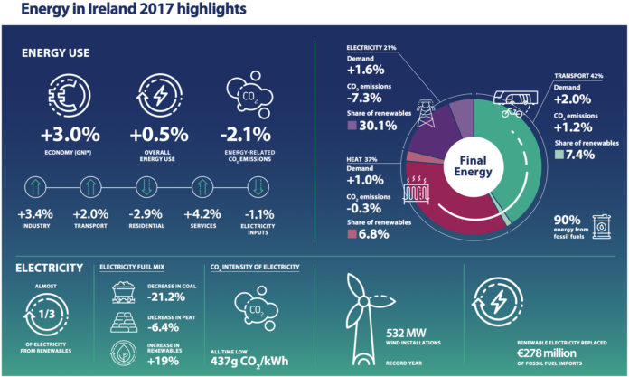

The latest national data and trends on energy use and renewable energy in Ireland, shows a 0.5% increase in energy demand as the economy grew by 3.0% – this is according to the Sustainable Energy Authority of Ireland’s (SEAI) annual Energy in Ireland report.
Ireland continues to face a challenge in reducing reliance on fossil fuels for transport, heating and electricity production, with over 90% of all energy used in 2017 from fossil fuels.
However, the report pointed to a reduction of 2.1% in carbon dioxide emissions from energy used in 2017, mainly due to increased electricity generation from wind, with record levels of capacity installed in 2017, making Ireland a world leader in renewable electricity.
TRANSPORT CHALLENGES
The 2018 report also shows energy demand in transport increased by 2% in 2017.
Commenting on the urgent need for action to address our energy challenges, Jim Gannon, CEO of SEAI, said, “Transport represents the single largest sector of energy use, half of which is private cars. We need a rapid transition from diesel and petrol to electric vehicles. Government funded incentives of varying types have driven a rapid growth in electric car sales, doubling year on year since 2015.
“Ireland’s geographical extent makes it well suited to electric cars and, while not every driver can switch in the short term, we must ensure that it is considered a real option for the majority of new car purchases from now on. A transition to a largely electrified passenger fleet, along with the consideration of alternative fuels for commercial, public transport and freight is essential,” he said.
For more information visit: www.seai.ie

A target of 33% energy efficiency improvement is to be achieved by all Irish public bodies by 2020. View the results for 2018 Annual Report on Public Sector Energy Efficiency Performance:
View results here:
https://www.seai.ie/energy-in-business/monitoring-and-reporting/public-sector-results/

